**DP 200 Printing Bed Handle DIY**

1. Download the *.gcode file from the website.
2. For PLA, please download the 3DWOX Bed Handle_PLA.gcode.
3. For ABS, please download the 3DWOX Bed Handle_ABS.gcode.

※ 3DWOX Desktop will not let users print PLA gcode files with ABS cartridge installed and vice versa.

1. Print the *.gcode file through the 3DWOX Desktop Software.
2. The *.gcode file will print the main body and the handle, separately. Please assemble the parts by pushing the handle into the main body.
3. We suggest applying super glue or any other high-strength adhesive after the assembly.

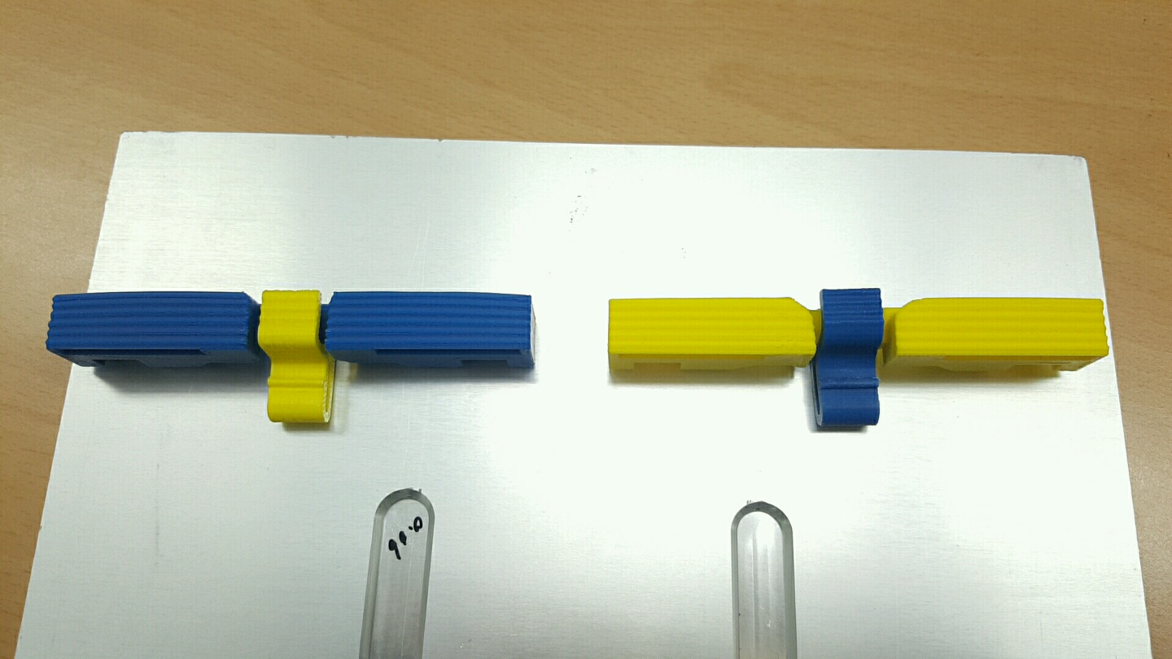

1. Pull the Printing Bed out of the 3DWOX.

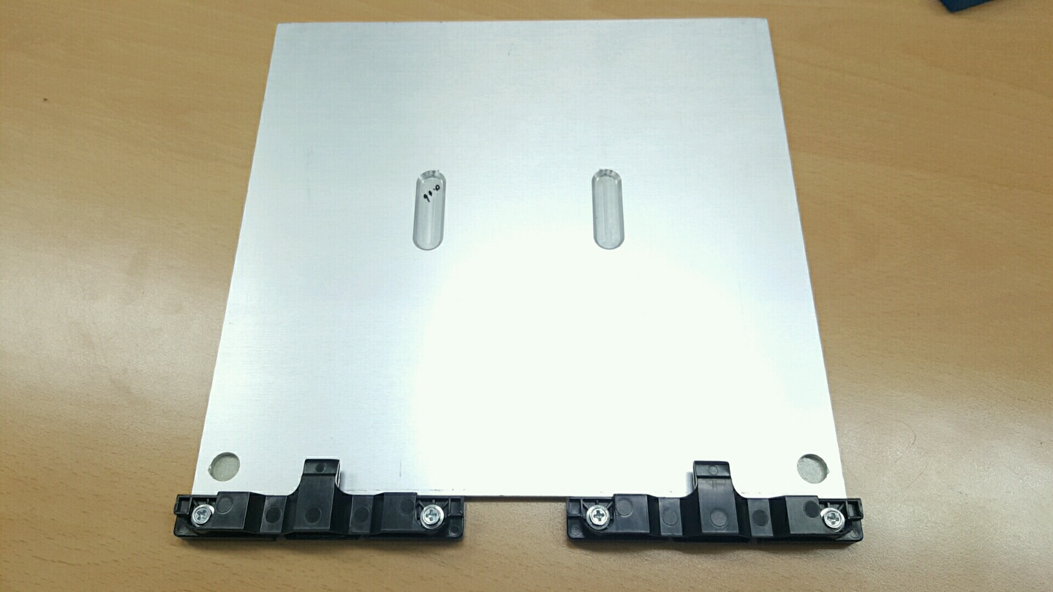

1. Loosen the four screws off of the Bed Handle.

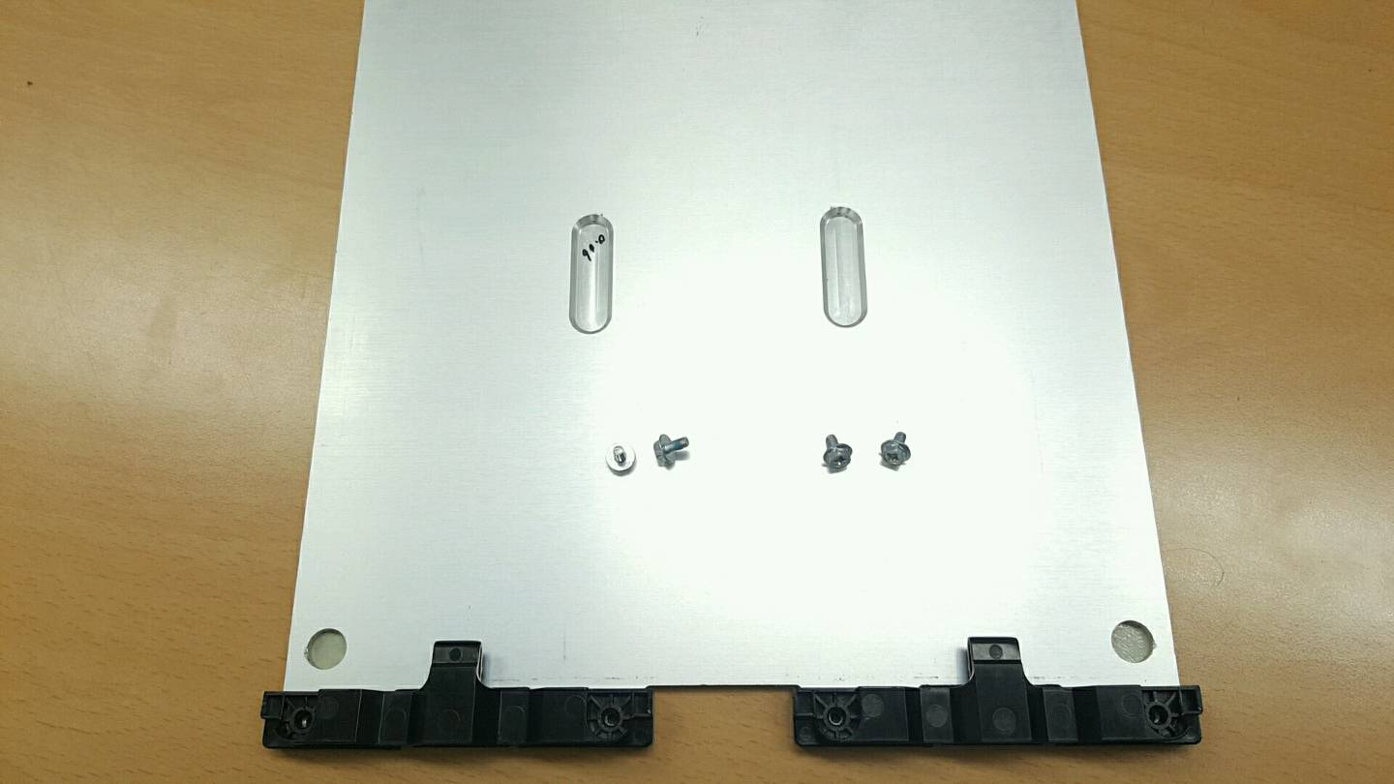

1. Pull the original handle off of the Printing Bed.

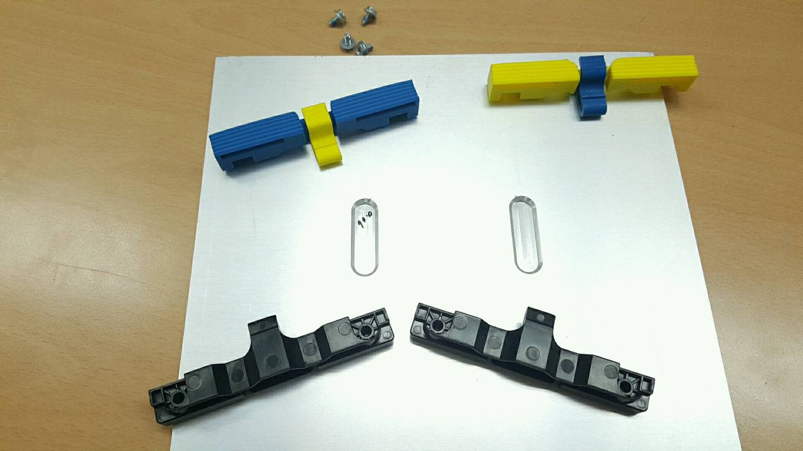

1. Push the new handle in and tighten the screws.

* CAUTION! Strong Tightening of the screws will result in the crack on the new bed handle!
* Please tighten the screws slightly until applying strength is needed and with care!

